Project Design Phase-II

Technology Stack (Architecture & Stack)

|  |  |
| --- | --- |
| Date | 08 November 2022 |
| Team ID | PNT2022TMID37519 |
| Project Name | Fertilizers Recommendation System For Disease Prediction |

Technical Architecture:

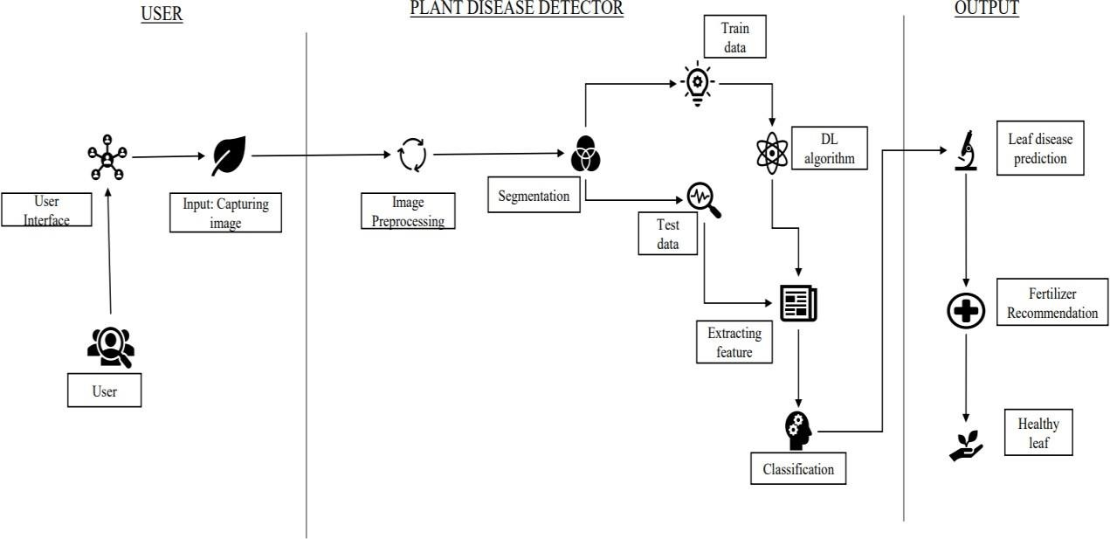

Table -1: Components & Technologies :

|  |  |  |  |
| --- | --- | --- | --- |
| **S.NO** | **Component** | **Description** | **Technology** |
| 1, | User Interface | How user interacts with the website. | HTML,CSS, etc,. |
| 2, | Disease Prediction | Here the disease in the leaf is predicted | Keras,CNN. |
| 3. | Fertilizer Recommendation | The fertilizer is recommended for the predicted disease | User interface, HTML, CSS. |
| 4. | Dataset | The training and testing data are collectively stored | Kaggle.com, data.gov, UCI machine learning repository, etc. |
| 5. | File Storage | File storage requirements | IBM, Local File system. |
| 6, | Modules | Purpose of deep learning  modules | Image Recognition  Modules,etc. |
| 7. | Infrastructure(Server) | Application development on Local System-local server configuration: | Local File system. |

Table – 2: Application Characteristics:

|  |  |  |  |
| --- | --- | --- | --- |
| **S.NO** | **Characteristics** | **Description** | **Technology** |
| 1. | Opensource Framework | List of the opensource framework used | Open source-PyCharm, anaconda navigator, flask  framework. |
| 2. | Login | List of the access control implementation | Security - OWASP |
| 3. | Scalable Architecture | Justify the scalable architecture | PyCharm |
| 4. | Availability | Justify the availability of  website | Web application access to  all. |
| 5. | Performance | Design consideration for the performance of the website | Convolutional Neural Networks. |